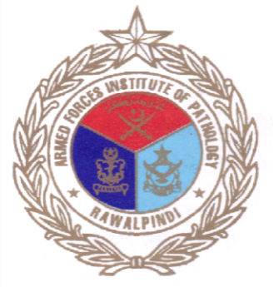
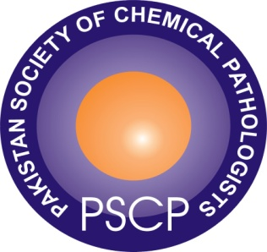

7th Annual Course on Chemical Pathology
Pakistan Society of Chemical Pathologists
www.PSCP.org.pk
Theme: Paediatric Metabolic Disorders: Challenges and Wayforward

13th and 14th May 2016

at Armed Forces Institute of Pathology Rawalpindi
Seminars on:
- Paediatric Metabolic Disorders
- Proficiency Testing and Laboratory Accreditation
Registration: PKR: 1500/-, MLTs: PKR: 1000/-
For Further Information: Mr. Usman Academic Office, Chemical Pathology, AFIP Rawalpindi (0346 53369659) Email: ijaz_aamir@hotmail.com For Detailed programme visit: www.PSCP.org.pk

